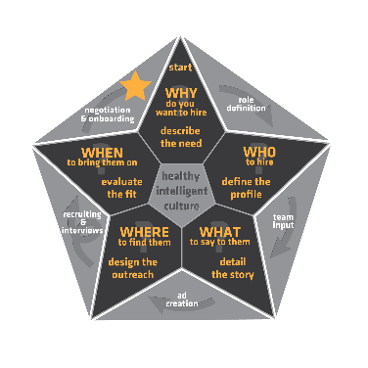Interview Form

|  |  |  |  |
| --- | --- | --- | --- |
| Candidate Name: | candidate | | |
| Role Applied for: | role | Date: | date |
| Interviewer: | name | Candidate Phone: | phone |
| Location: | location | Candidate email: | email |

What have you been up to these days?

|  |
| --- |
| answer |

In your current role, what are your favourite parts?

|  |
| --- |
| answer |

If you could subtract elements of your current role, what would you give away?

|  |
| --- |
| answer |

Design your ideal role in what you are applying for. Hours, size of team, size of company, responsibilities, balance, etc.

|  |
| --- |
| answer |

What do your friends praise you for being able to do that they wish they could do?

|  |
| --- |
| answer |

Tell me about your last environment. Walk me through a typical day (dig for details)

|  |
| --- |
| answer |

How many people on a project or team?

|  |
| --- |
| answer |

What is the most important accomplishment in your career so far?

|  |
| --- |
| answer |

What is the most embarrassing moment in your career? How did you handle it? What did you learn from it?

|  |
| --- |
| answer |

What is your greatest weakness? What would your friends say you need to work on?

|  |
| --- |
| answer |

Tell me about someone who is better than you in an area that really matters to you?

|  |
| --- |
| answer |

How do you handle apologies? Giving and accepting

|  |
| --- |
| answer |

Tell me about the hardest you ever worked at something?

|  |
| --- |
| answer |

What sort of hours do you usually work?

|  |
| --- |
| answer |

How would you describe your personality?

|  |
| --- |
| answer |

What do you do that others in your life might find annoying?

|  |
| --- |
| answer |

What kind of people annoy you the most? How do you deal with them?

|  |
| --- |
| answer |

What is something that most people believe that you disagree with? Why?

|  |
| --- |
| answer |

What are you hoping to get out of this role? What do you want to walk out of here with?

|  |
| --- |
| answer |

What do you love to do when you’re not working?

|  |
| --- |
| answer |

What do you think is fair compensation to do this role well? What would be an insult?

|  |
| --- |
| answer |

What’s one thing you wish more people knew about you?

|  |
| --- |
| answer |

What is at the intersection of what you’re great at and what you love to do?

|  |
| --- |
| answer |

What do you really want to know before you accept an offer from us?

|  |
| --- |
| answer |

If you had $100,000,000, after you had fun, what would you settle into doing?

|  |
| --- |
| answer |