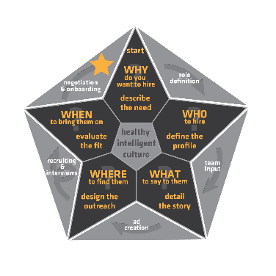Reference Inquiry Form

|  |  |  |  |
| --- | --- | --- | --- |
| Candidate Name: | candidate | Position: | position |
| Reference from: | referee | Date taken: | date |
| Ref. Organisation: | company | Reference Phone: | phone |
| Your name: | yourname | Reference email: | email |

What was the role they were doing when you worked together?

|  |
| --- |
| answer |

What was your relationship to them? | How long did they work there? | How long ago?

|  |  |  |
| --- | --- | --- |
| answer | answer | answer |

What did they excel at?

|  |
| --- |
| answer |

If you could coach them, what would you encourage them to work on?

|  |
| --- |
| answer |

How did they fit in with the team?

|  |
| --- |
| answer |

How did they handle coaching? From above? From peers? From subordinates?

|  |
| --- |
| answer |

What is the best way to coach them?

|  |
| --- |
| answer |

Are they self-motivated or reliant on direction?

|  |
| --- |
| answer |

Tell me about their problem-solving abilities

|  |
| --- |
| answer |

How do they deal with stress?

|  |
| --- |
| answer |

Any issues that might have affected their performance or reliability?

|  |
| --- |
| answer |

In your opinion, why did they leave the company?

|  |
| --- |
| answer |

Would you rehire the candidate? Yes:  No:  Maybe:  Why?

|  |
| --- |
| answer |

As we present this candidate to the hiring manager, what would you say about their ability to contribute to the new team?

|  |
| --- |
| answer |

Role Specific Questions:

Enter what question you want to ask here and type the answer below

|  |
| --- |
| answer |

Your comments or notes regarding the reference check:

|  |
| --- |
| answer |