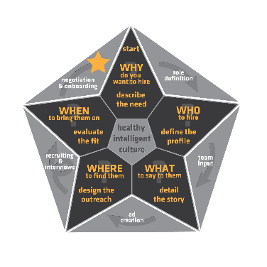Employee Onboarding Process

|  |  |
| --- | --- |
| **Employee Name:** | Employee |
| **Start Date:** | **start** |
| **Reporting to:** | report |
| **Mentor:** | mentor |

**First Steps:**

**Job offer ready**

**Employee Information Sheet completed**

**Reference checks done**

Salary confirmed

**Other Documents ready**

**Welcome Letter**

**Tax forms**

**Drivers Abstract**

**Background check**

**After Offer is accepted:**

**Order laptop or workstation**

**Desk set-up and clean**

**Training Path selected and ready**

**Mentor selected**

**Announcement to team about new start**

**Starting Day:**

**Have them in 30 minutes early to settle in**

**Introduce everyone at the morning meeting**

**Go through login information and needed software**

**Start training plan**

**1 week, 1 month, 3 month, 6 month and 1 year check-ins booked in calendars**

**Who must they meet:**

**HR**

**Administration**

**Technology**

**CEO**

**Mentor**